1. First go into the asm_ntt512 function.

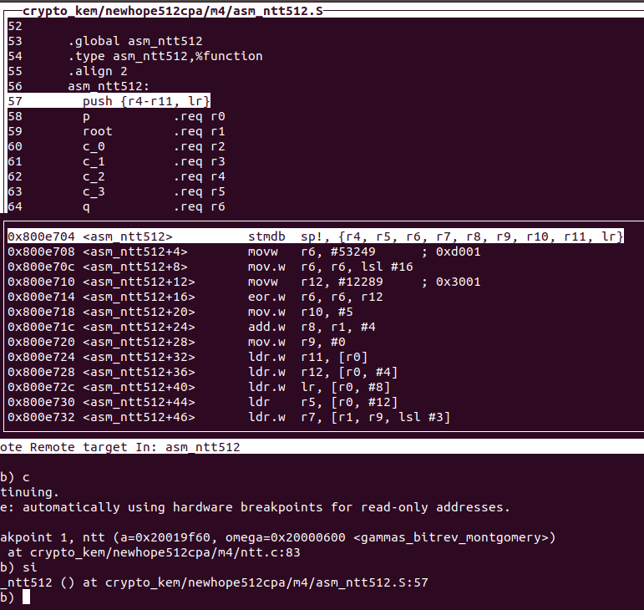

1. Then go to the “loop” count number instruction

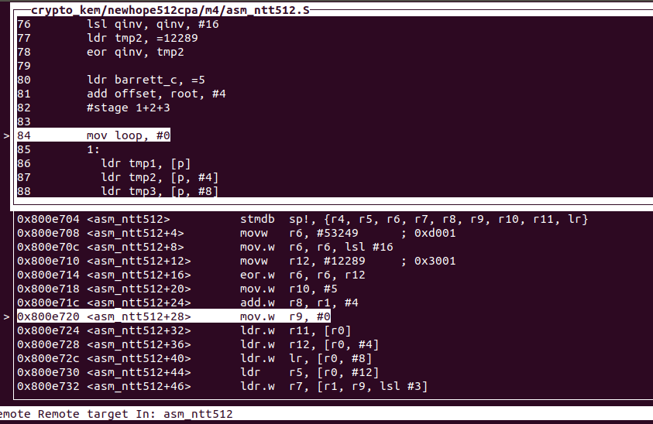

After that there is one more instruction uses the loop.

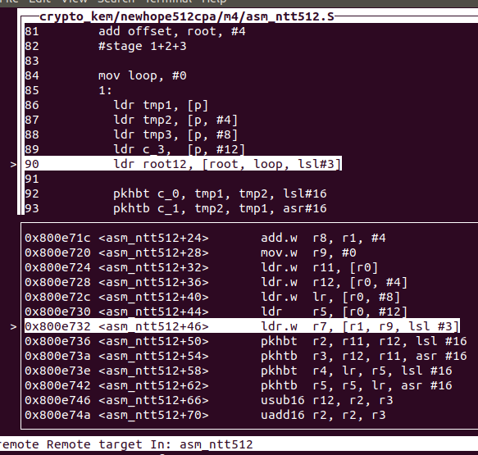

At the end of the loop, there is a compare and a conditional branch instruction.

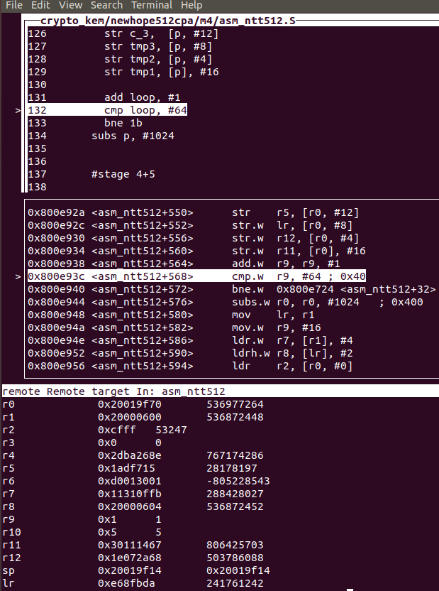

So if we can modify the conditional branch instruction, the loop will only implemented once. So maybe a few butterflies are computed.

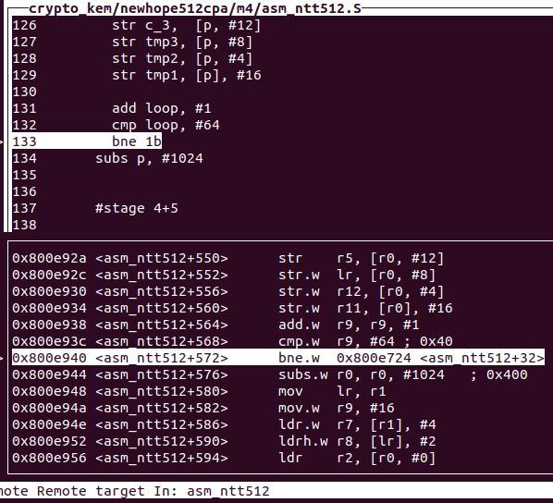

The stage latter like 4+5 and 6+7 might be the same.